Topic 2 – Session Fixation - Proof of Concept

1. Objective of the PoC
The objective of this Proof of Concept is to demonstrate a session fixation vulnerability caused by the failure to regenerate the session identifier after successful authentication.
This PoC shows how a session identifier created before login remains unchanged after login, allowing an attacker who knows the session ID to reuse it and gain unauthorized access.

2. Vulnerability Description
Session fixation occurs when a web application:
- Issues a session identifier before authentication, and
- Continues using the same session identifier after authentication.
In such cases, any party that already knows the session identifier can reuse it once the victim logs in, resulting in unauthorized access.

3. Target Application Details
- Site Name: Acunetix Test Website
- URL: http://testphp.vulnweb.com/login.php
- Category: Vulnerable Web Application
- Type: Test application for Acunetix Web Vulnerability Scanner
- Purpose: Web application security testing
- Overall Usage: Widely used globally for vulnerability demonstrations

4. Preconditions Observed
Based on application behaviour:
- Session identifier is created before login, No session regeneration after authentication
- Authentication state is directly tied to a reusable cookie
- Server trusts the session cookie without validating its lifecycle

Proof of Concept – Sequential Execution Log

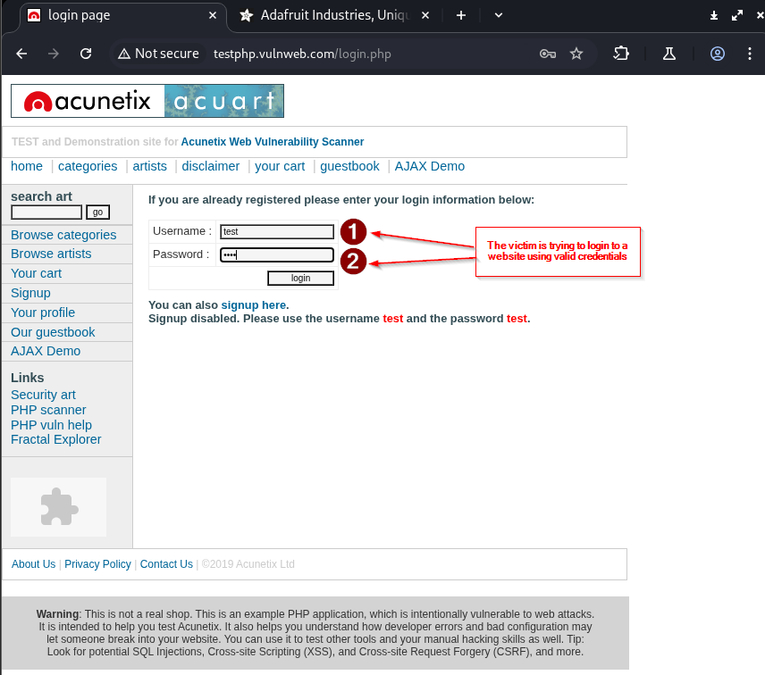
Figure 2.1 – Login Attempt
- The user submits valid login credentials.
- No indication of a new session identifier being generated during login.
Observation:
Authentication proceeds without negotiating a fresh session ID.

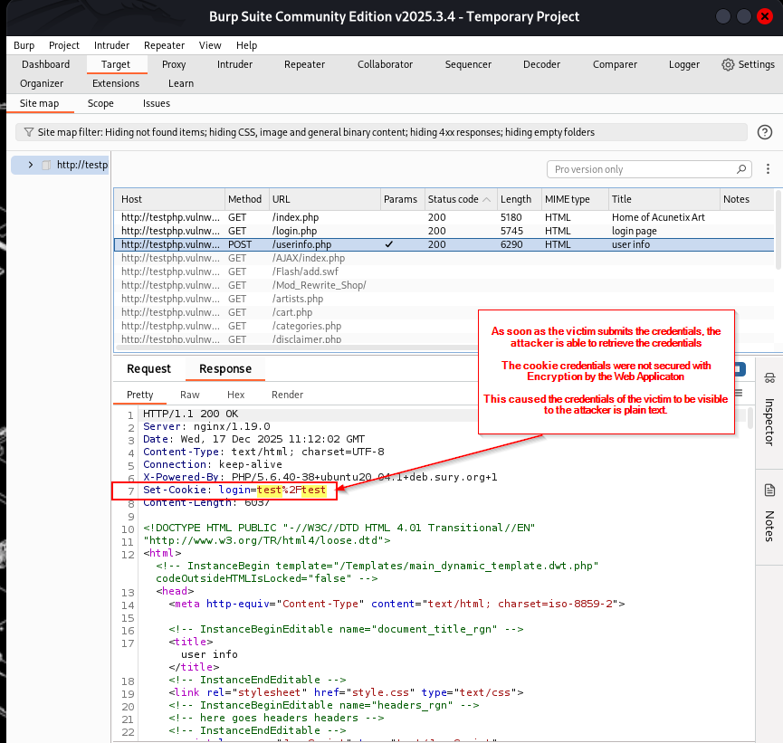
Figure 2.2 – Cookie Issued on Login
- The server sets a cookie:
  - Set-Cookie: login=test%2Ftest
- The cookie directly reflects authentication state.
Key Finding:
- No session regeneration mechanism is visible.
- This indicates weak session design.

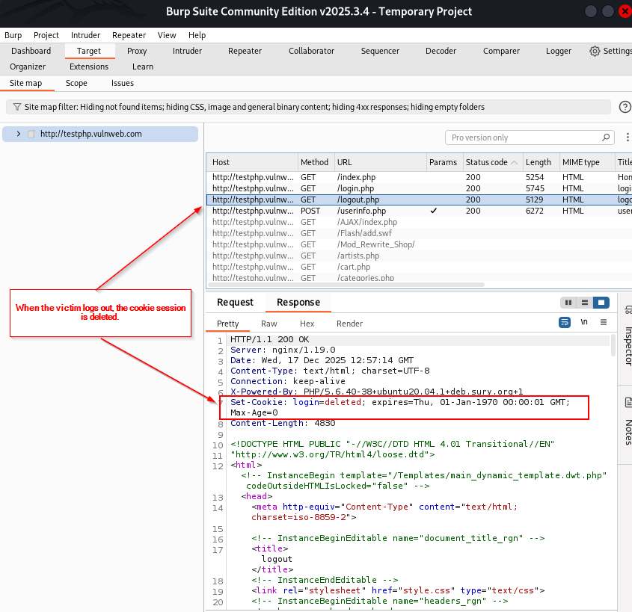
Figure 2.3 – Logout
- The user logs out of the application.
- The cookie is deleted using:
  - expires=Thu, 01-Jan-1970
(Old date is used to delete the cookie’s existence at current time.)
Observation:
The same cookie controls authentication state, confirming reliance on a single reusable identifier.

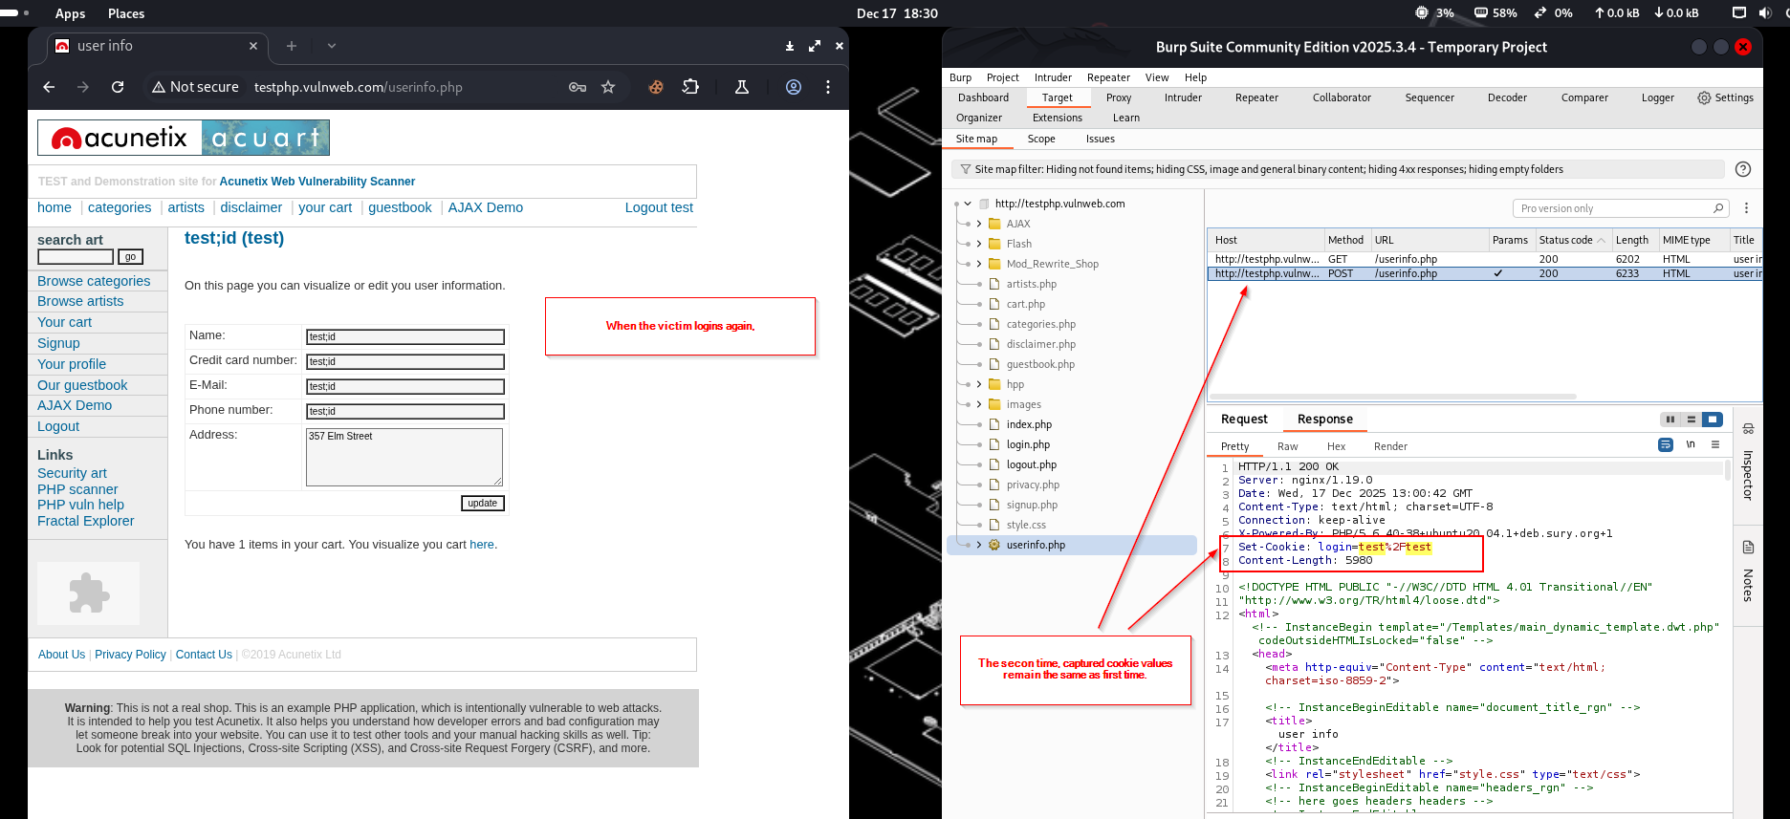
Figure 2.4 – Login Again
- The user logs in again with valid credentials.


Figure 2.4 – Login Again
- The exact same cookie value is reissued.
Critical Evidence:
No new session token is generated after login.
This conclusively demonstrates session fixation.

6. Result
- The application reuses the same session identifier across multiple logins.
- Any attacker who knows this identifier prior to login can reuse it.
- Authentication is bypassed without stealing credentials.

7. Security Impact
- Unauthorized session reuse
- Account takeover
- Authentication bypass
- Session compromise without password theft

8. Key Insight
This vulnerability exists due to improper session lifecycle management, not browser behaviour or user error.
The browser behaves correctly by storing and sending cookies; the flaw lies entirely in the server’s failure to regenerate session identifiers after authentication.

9. Vulnerability Classification
- Type: Trust-Based Session Management Vulnerability
- Category: Session Fixation
- Root Cause: Failure to regenerate session ID after login

10. Mitigation Recommendations
- Regenerate session identifiers immediately after successful login
- Invalidate all pre-authentication session IDs
- Separate authentication state from reusable cookies
- Enforce strict session lifecycle controls
- Regularly audit session handling logic

11. References
- OWASP Session Management Cheat Sheet
https://cheatsheetseries.owasp.org/cheatsheets/Session_Management_Cheat_Sheet.html
- RFC 6265 – HTTP State Management Mechanism
https://datatracker.ietf.org/doc/html/rfc6265
- Acunetix Vulnerability Test Website
http://testphp.vulnweb.com

